TAMU Gardens In Focus
Program Evaluation Overview

Mission:
To broaden the participation of students in the fields of geosciences and environmental sciences

Impact:
To fulfill an existing gap in access and exposure to fieldwork across several disciplines for young scholars.

Program implementation activities (I):
- Establish and manage a time-series program on-campus
- Provide professional learning opportunities in classic oceanographic techniques
- Promote on-campus research opportunities across the environmental sciences

Program goals (G):
- Increase student empowerment to perform discipline-specific work in their field
- Increased student motivation to explore research opportunities and careers that involve fieldwork
- Improve student coursework experiences
- Increase interdisciplinary engagement in field-based teaching and research experiences

Program Description:
The evaluand is the TAMU Gardens In Focus (GiF) program. TAMU GiF program is a time-series sampling project that includes a convergence of field-based teaching and research experiences. The mission of the TAMU GiF program is to broaden the participation of students in the fields of geoscience and environmental sciences. The anticipated impact of TAMU GiF is to fulfill an existing gap in access and exposure to fieldwork across several disciplines for young scholars. To this end, four long-term project goals related to closing the gap in access and exposure to fieldwork guide the project's efforts:
- Increase student empowerment to perform discipline-specific work in their field
- Increased student motivation to explore research opportunities and careers that involve fieldwork
- Improve student perceptions of their coursework experience
- Increase interdisciplinary engagement in field-based teaching and research experiences
The primary TAMU GiF implementation strategies include: (a) establishing and managing a time-series program on-campus, (b) providing professional learning opportunities in classic oceanographic techniques, and (c) promoting on-campus research opportunities across the environmental sciences.

Evaluation Plan:
The overall purpose of this evaluation is to support annual reporting and continuous program improvement for the TAMU GiF program. The external evaluator will measure qualitative and quantitative aspects of the project implementation and goals using program records and a post-experience participant survey. Formative evaluation activities will verify the extent to which the program was implemented as planned (e.g., on-campus time-series program, professional learning experiences, interdisciplinary engagement). Summative evaluation will measure progress towards achieving program goals (e.g., student empowerment, motivation, and coursework experiences; interdisciplinary engagement). Figure 1 shows the logic model guiding the evaluation.
Figure 1
TAMU Gardens in Focus Logic Model
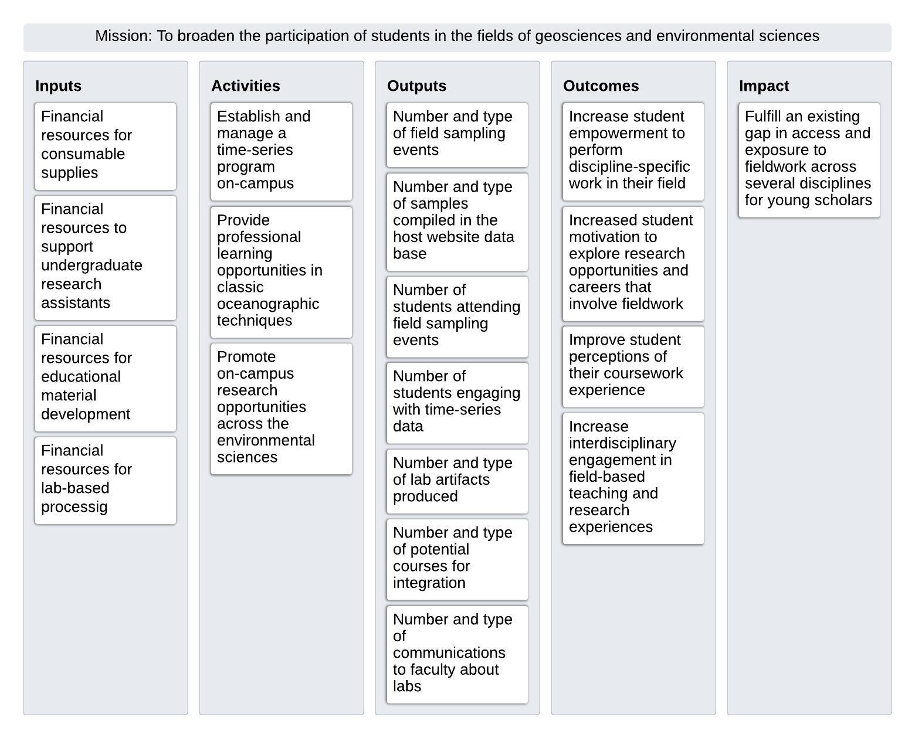
Table 1 illustrates how each suggested evaluation question is aligned with data collection. The overarching questions guiding the evaluation are:
- To what extent was the TAMU GiF program implemented as designed?
- To what extent were the TAMU GiF goals achieved?
- What unanticipated outcomes emerged as a result of the project?
- What is transferable, replicable, and scalable as a result of the project?
Table 1
Proposed Evaluation Questions and Data Sources
Evaluation Questions | Data Sources | Indicator
I#1: Establish and manage a time-series program on-campus
To what extent were field science experiences offered? | Program records | Number and type of field sampling events
To what extent were time-series analysis experiences offered? | Program records | Number and type of samples compiled in the host website data base
I#2: Provide professional learning opportunities in classic oceanographic techniques
To what extent did students engage in field science experiences? | Program records | Number of students attending field sampling events
To what extent did students engage in time-series analysis experiences? | Program records | Number of students engaging with time-series data
To what extent were educational materials produced? | Program records | Number and type of lab artifacts produced (e.g., how-to written guides, videos, and explanations of why we are conducting this sampling)
I#3: Promote on-campus research opportunities across the environmental sciences
How many courses were identified as candidate courses for the field work and time-series lab experiences? | Program records | Number and type of courses FA26
To what extent did outreach occur regarding the lab experience opportunities? | Program records | Number and type of communications to faculty
G#1: Increase student empowerment to perform discipline-specific work in their field
To what extent did students feel they increased their skills in aquatic field methods? | Survey | Ratings of perceived gains or confidence in skills
To what extent did students feel a sense of belonging as a scientist? | Survey | Ratings of perceived identity and belongingness
G#2: Increased student motivation to explore research opportunities and careers that involve fieldwork
To what extent did student interest in pursuing additional on-campus research opportunities, graduate school, and careers in a related field change? | Survey | Interest ratings for on-campus opportunities, grad school, and careers
G#3: Improve student perceptions of their coursework experience
To what extent did the field experience module contribute to the overall course learning experience? | Survey | Perceived contributions to learning and relevance to professional skills
To what extent did the time-series analysis module contribute to the overall course learning experience? | Survey | Perceived contributions to learning and relevance to professional skills
G#4: Increase interdisciplinary engagement in field-based teaching and research experiences
To what extent were the modules integrated in coursework across scientific disciplines? | Program records | Number and type of courses integrating lab modules

Post-Experience Participant Survey:
- See attached TAMU Gardens in Focus Post-Experience Survey

